**FINAL SPECIFICATION DOCUMENT**

**FlyAway (An Airline Booking Portal)**

**Table of contents**

1.Project and developer details

2.Sprints planned and the tasks achieved

3.Algorithms and flowcharts of the application

4.Core concepts used in the project

5.Links to the GitHub repository to verify the project completion

***1.Project and developer details***

**Project objective:**

As a Full Stack Developer, design and develop an airline booking portal named as FlyAway. Use the GitHub repository to manage the project artifacts.

**Background of the problem statement:**

FlyAway is a ticket-booking portal that lets people book flights on their website.

***2.Sprints planned and the tasks achieved***

For developing this application, I have considered 3 sprints each of 3 hrs.

1st 3-hour:

* Deciding the flow of the application
* Defining class names and functions within
* Preparing the eclipse IDE to start code

2nd 3-hour:

* Writing code for the problem statement proposed
* Code is split into several classes and each class output is checked side by side

3rd 3-hour:

* Testing the application that is developed with varies inputs.
* Pushing the code to GitHub
* Creating a word document that specifies the application capabilities and user interactions.

***3.Algorithms and flowcharts of the application***

**Flow of the project:**

Step 1: Create a project in eclipse called “Flyaway”. Configure build path in the project, add server runtime to execute the project.

Step 2: Create UserLogin.java servlet, that’s requests for email and password of the user. If the user did not have login details, the user is redirected to create login credentials.

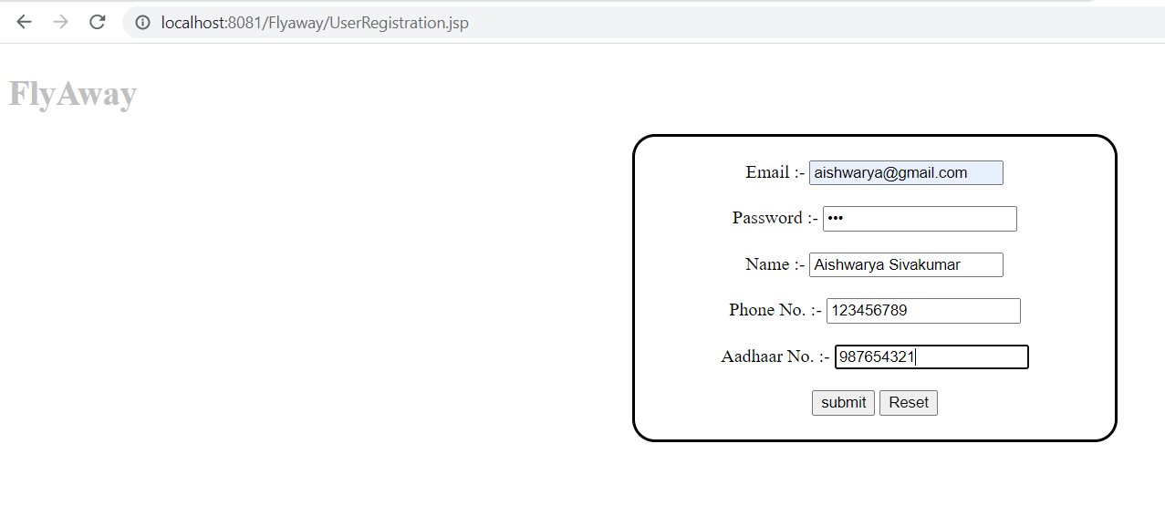

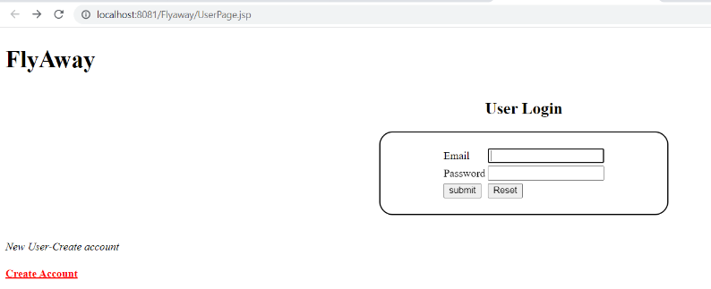

Step 3: After creating account, the user is redirected to UserPage.jsp, here the user’s mail id and password is validated.

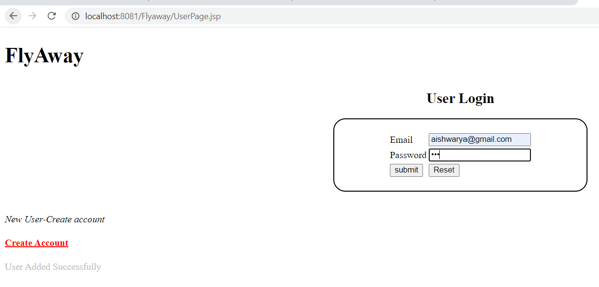

Step 4: After validation, in HomePage.jsp user is allowed to enter from, to, departure and travelers count in order to search for the available flight.

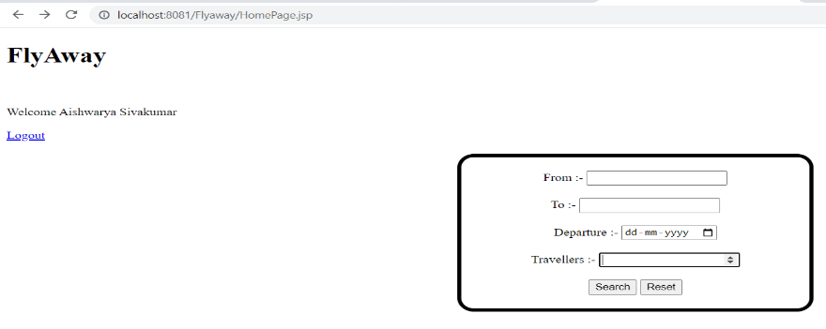

Step 5: Previously, in Mysql a schema called flyaway is created. There, 3 tables flights,user and admin is created.

Step 6: From the list of flights in the database, the user entered details is cross verified and it is checked for available flights.

Step 7: Thereafter available flights is displayed with its time, flight name and ticket price.

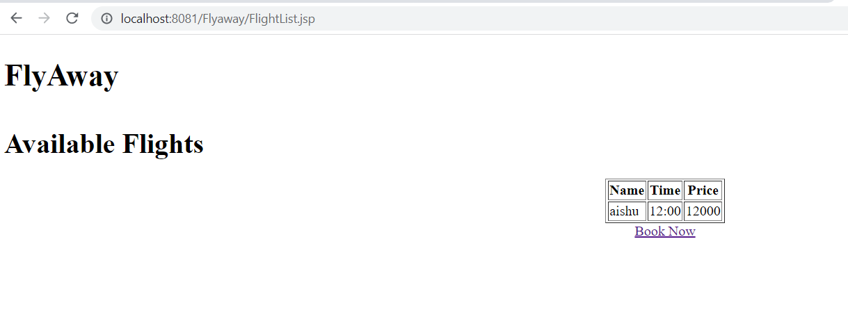

Step 8: There is an option enabled to book tickets. On clicking that will redirect to bookflight.jsp.

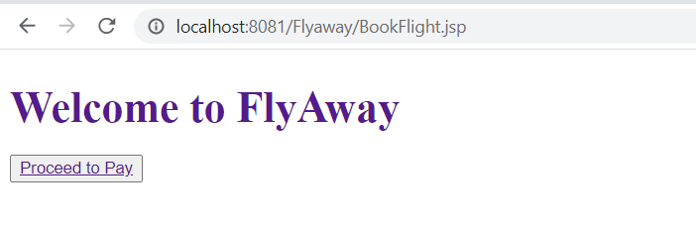

Step 9: On clicking proceed to pay button, payment.jsp will take over to neter email id and card details.

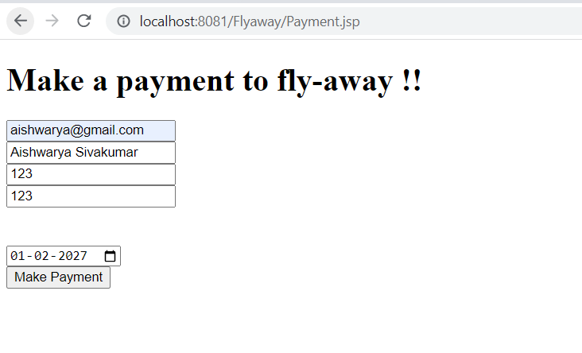

Step 10: After making payment, the call is redirected to FinalTicket.jsp where we will find the successful ticket booking with Passenger name, flight name, departure time and price.

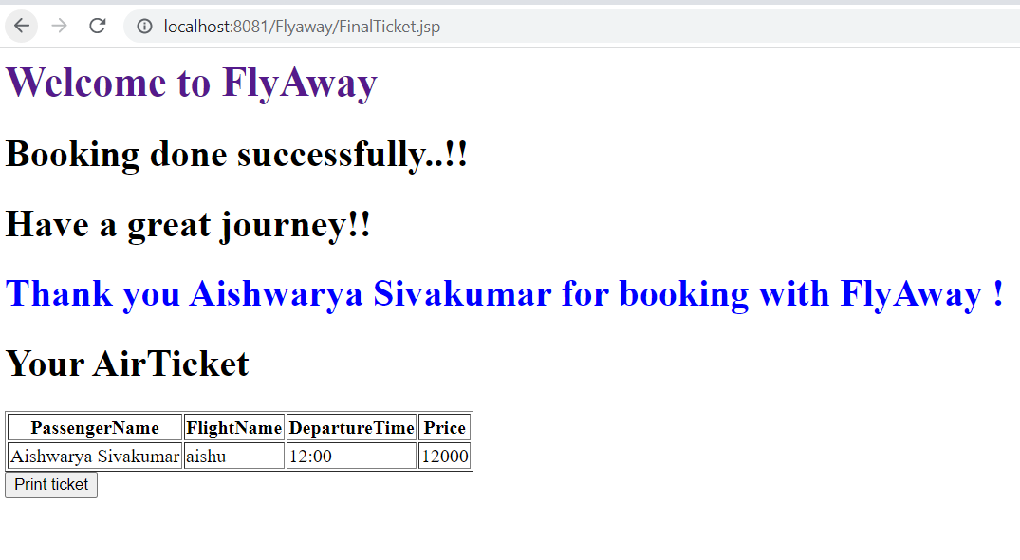

Step 11: Finally, print ticket option is enabled to print tickets.

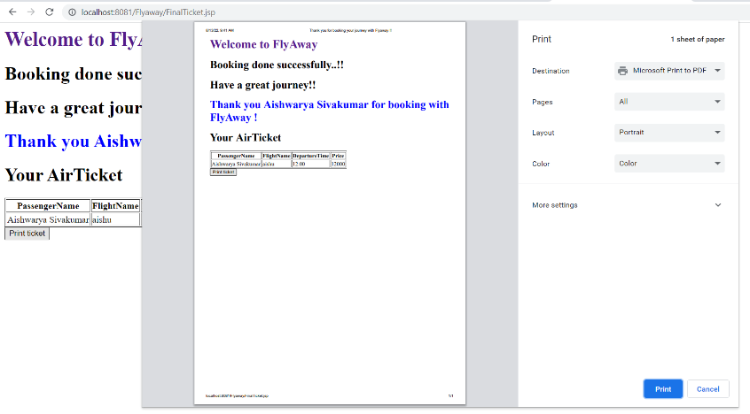

***4.Core concepts used in the project***

* Servlet
* Jsp
* JDBC
* Mysql

***5.Links to the GitHub repository to verify the project completion***

https://github.com/AishwaryaSivakumar48/Assisted_Project_work/tree/main/Flyaway